**Enhancing Efficiency and Minimizing Delays: A Comparative Study of Machine Learning Models for Forecasting Average Gate Arrival Delays at Newark Liberty International Airport**

*S. Carmona, R. Koutike, S. Meda, K. Shah, A. Varsada*

ABSTRACT – Flight delays are a significant concern in the aviation industry, impacting passengers, airlines, airports, and local economies. This study examines capacity and weather data at Newark Liberty International Airport (EWR) and evaluates the effectiveness of machine learning models in forecasting average gate arrival delay. The ensemble models, Random Forest Regressor and XGBoost Regressor, along with Linear Regression, K-Nearest Neighbors, and Neural Networks, were compared using hourly data from 2018 to 2022. The results, measured by Root Mean Squared Error (RMSE), demonstrate that the ensemble models outperformed the other models in predicting the Average Gate Arrival Delay.

KEYWORDS - *Machine Learning, Linear Regression, Neural Networks,* K-Nearest Neighbors*, Ensemble Models*

1. INTRODUCTION

The aviation industry is crucial in connecting people and transporting goods worldwide. However, flight delays are a significant issue facing this industry. These delays can cause passengers frustration, increase airline operational expenses, and lead to economic losses for airports and local economies.

Gate arrival delays at an airport can be affected by various factors, including gate departures[1], airport arrival capacity[2], airborne delays[3], and block delays[4]. Additionally, the time taken for taxiing[5] is a significant factor determining the arrival gate delay at an airport. This paper focuses on the Newark Liberty International Airport Facility (EWR) and aims to analyze its airport performance regarding flight gate arrival delays.

This case study aims to evaluate and compare the effectiveness of ensemble machine learning models, including Random Forest and XGBoost Regressor, against other machine learning models, such as Linear Regression, K-Nearest Neighbors, and Neural Networks, in forecasting Average Gate Arrival Delay. This study also aims to identify the factors contributing to average gate arrival delays and contribute to the literature on the aviation industry by evaluating the performance of the machine learning models using hourly data from the Federal Aviation Administration Airport Analysis and Efficiency Data from 2018 to 2022. The study utilized the Python programming language and essential libraries, like Pandas and Scikit-Learn, to analyze and develop the models to evaluate their performance. The study's results assist airports in better planning for connection flights, ensuring available gates, continuous flights, and more capacity by enabling them to predict the typical gate arrival delay.

1. LITERATURE RESEARCH

According to Dr. Diana (2018 research), taxi out time has demonstrated that the airport can be tracked based on arrival and departure capacity. An airport's capacity changes based on numerous factors and taxi-in and taxi-out delays since few changes can be made to the flight-to-gate assignment based on the study made by Zoutendijk (2021). Machine learning models, like ridge regression and Lasso, can predict the data variables affecting the airport's delays and capacity, which should work individually with the flight and weather data. In addition, the research showed that supervised machine learning models, specifically ensemble models, help predict the reasons behind gate arrival delays at the airport.

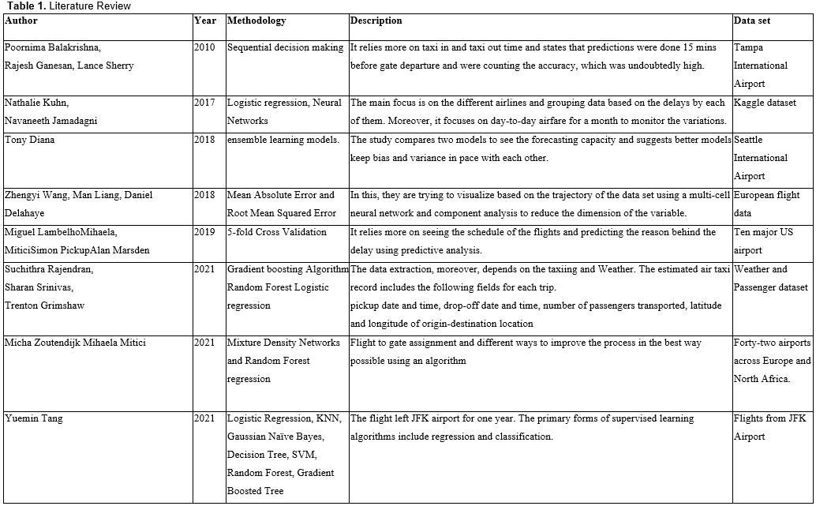

1. METHODOLOGY
   1. Data Samples

The data originated from the Aviation Systems Performance Metrics (ASPM) data warehouse,[6] which includes information on operations and delays. The dataset used in the project was a combination of the ASPM Efficiency[7] data, which provides information on the System Airport Efficiency Rate (SAER) and Terminal Arrival Efficiency Rate (TAER) metrics, and ASPM Airport Analysis[8] data. These datasets provide information on aircraft departure and arrival times and flight delays for the ASPM77 airports compared to the schedule and flight plan times[9].

The datasets from both sources are from 2018 to 2022. The ASPM Efficiency had weather data which consisted of 19 columns and 43819 observations. The ASPM Airport Analysis consisted of 17 columns and 41884 observations. It was decided to join the data from both sources by day and hour, resulting in 34 columns and 41873 rows for the initial dataset for the analysis and transformation of data.

* 1. Variables

**Table 2** describes the initial 34 columns used for the project analysis. Nine variables were selected for the regression models according to the LASSO and RIDGE models coefficients shown in **Appendix A**.

These models suggested independent variables having coefficients not equal to zero. Among these, the Linear Regression rejected the null hypothesis suggesting a p-value < 0.05 for those variables that have a positive autocorrelation with the dependent variable, Average Gate Arrival Delay. Finally, nine variables were selected, Average Taxi Out Delay, Efficiency AAR, Arrivals for Metric Computation, Average Taxi Out Time, Average Block Delay, Average Airborne Delay, Departures for Metric Computation, % On-Time Gate Arrivals, and Capacity AAR.

Many Machine Learning algorithms perform better when numerical input variables are scaled, especially algorithms like Gradient descents, KNN algorithms, and linear regression[10]. Since the study is based on these types of Machine Learning models and the nine selected variables are numerical with different ranges, a Min-Max Scaler was used to transform the data by scaling the features between the 0 – 1 range, helping preserve the shape of the original distribution[11].

**Table 2.** Explanatory variables

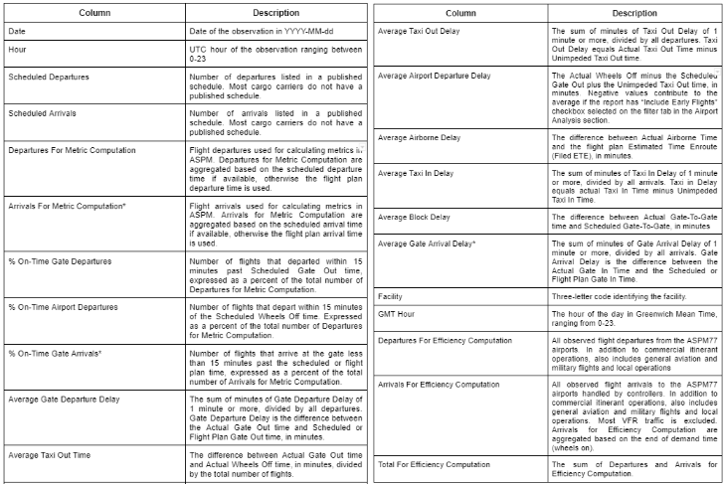

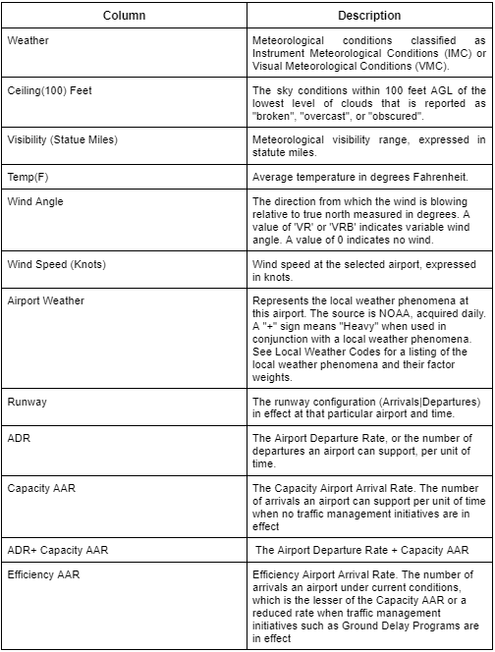

* 1. Exploratory Data Analysis (EDA)

The dataset consisting of 41,873 observations was used to conduct Exploratory Data Analysis (EDA) obtained by joining datasets mentioned earlier. Pandas Profiling was used to analyze the data, which involved checking for skewed numeric values, unbalanced categorical values, and missing values. The analysis revealed that the data had seasonal trends, which prompted the study to perform a more detailed analysis. The data was segmented by year, month, hour, and weekdays to investigate the timeline progress of the target variable for each category. The study revealed that the hours with the most extended average gate arrival delay were 6 pm and 8 pm, which also happened to be the hours with the most scheduled arrivals.

Similarly, the study found that the summer months (June, July, and August) had the most extended average gate arrival delays. Interestingly, Saturdays had the shortest average gate arrival delay minutes, while Thursdays had the longest. This could be attributed to the fact that people prefer to travel on weekends, resulting in fewer scheduled arrivals on Saturdays, while Thursdays and Fridays are more popular for traveling. Furthermore, the researchers noticed that the number of flight delays was significantly lower in 2020 due to the COVID-19 pandemic and the many travel bans that were in effect between March 2020 and July 2022. However, apart from the year 2020, seasonal changes were observed in average gate arrival delays, but no significant trends were detected over the years. Moreover, the data confirmed that Instrument Meteorological Conditions (IMC) weather has the greatest Average Gate Arrival Delay, which is understandable since IMC exists during rain, low clouds, or reduced visibility[12].

* + 1. Handling Missing Values

Dealing with missing values is critical when analyzing a dataset or creating any machine learning model since the algorithms can only process numerical data like floats or integers. Null or NaN values, on the other hand, will not be recognized by the model and will result in errors.[13]

To determine the total number of missing values, the Pandas Profiling library was used. Also, it helped to determine the total number of missing values per feature and their respective percentages from the total.[14] In addition, only five columns had missing data from the entire dataset, one with over 80% of missing values (Airport Weather).

**Table 3.** Missing values percentages from total

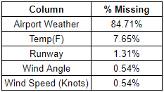

To address missing data in the dataset, the following procedure was followed:

* Airport Weather → As 84% of the data was missing, it was decided to drop the column as imputing such a large amount of missing data was not feasible.
* For numerical columns like Temp (F) and Wind Speed (Knots), → The null values were replaced with the average of each column.
  + Temp (F): 59.55 °F
  + Wind Speed (Knots): 8.295
* The rows with missing values for categorical variables such as Wind Angle and Runway were dropped from the dataset since the percentage of missing values for these variables was only 0.5% and 1%, respectively.
  + 1. Handling Outliers

The EDA revealed that some features were skewed, indicating they did not follow a normal distribution. This non-normal distribution could lead to errors in the model predictions by increasing the variance and affecting the accuracy of the regression algorithm used to detect the average gate arrival delay.[15]

A box plot distribution graph was created for each numerical column to identify outliers visually. Khan (2022) states that outliers are data points outside the Interquartile Range (IQR).[16] After placing the features with the most significant number of outliers, distplot graphs were created for each column to visualize their distribution and skewness. Then the outliers were removed using the IQR method, which involved dropping all data points below and above 1.5 times the IQR, resulting in a better-distributed dataset with 41096 observations.

* + 1. Benchmark Linear Regression Model

Once the relevant features were identified through LASSO and RIDGE, a basic Linear Regression Model was used as a benchmark to test the null hypothesis. The results showed that the null hypothesis was rejected, indicating a definite, consequential relationship between the features selected and the dependent variable.[17] This is because each of the p-values from the variables is equal to 0, meaning that the null hypothesis should be rejected.[18]

**Table 4**. Stats Model Linear Regression Summary

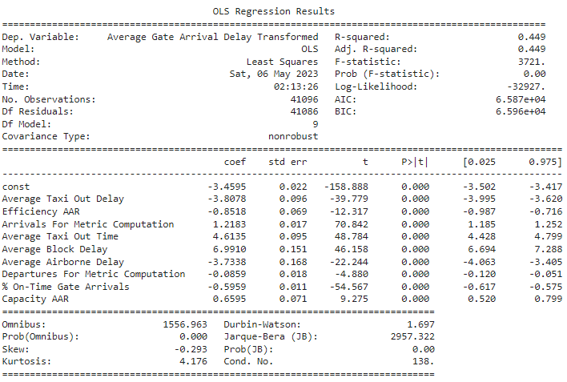

Analysis from the result in **Table 4**. of the stats model linear regression, the data is normally distributed (Jarque-Bera of 0), symmetrical between -0.5 and 0, and a tall distribution having a Kurtosis > 3. Finally, it shows a positive autocorrelation between the features and the dependent variable, Average Gate Arrival Delay.

* 1. Target Variable

Average Gate Arrival Delay is the dependent or target variable mentioned in Table 2. According to the Federal Aviation Administration in their ACRP Report, 104[19] passengers are more likely to consider delays in the gate arrivals. If it delays departing, it will be forgotten and forgiven if the flight arrives on time or early to the gate. Using the Average Gate Arrival Delay as our target variable could help the airports and airlines to prepare logistics for connection flights, gates available, and continuous flights. Most of all, it will allow airlines with customer satisfaction.

* + 1. Box-Cox Transformation

A Quantile-Quantile Plot (QQ plot) showing the normal distribution of the target variable (Average Gate Arrival Delay) was decided to see if it was normally distributed. Many statistical techniques (Machine Learning Models) assume the data is normally distributed.[20]

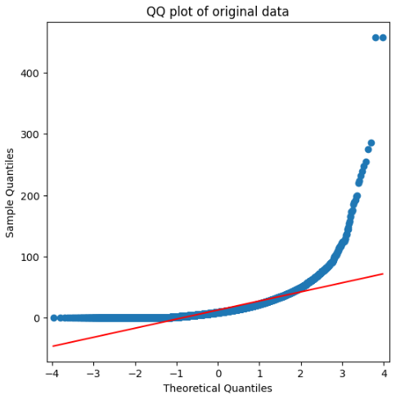  
**Fig 1.** Quantile-Quantile Plot Original Average Gate Arrival Delay Distribution

From **Fig 1**, it can be observed that the target variable is not normally distributed, which would cause the algorithm's predictions to be less accurate than expected because it takes into account white noise and bias[21]. Therefore, the Box-Cox parameter was calculated, resulting in 0.22. This parameter transformed the data into a normal distribution (**Fig 2**).

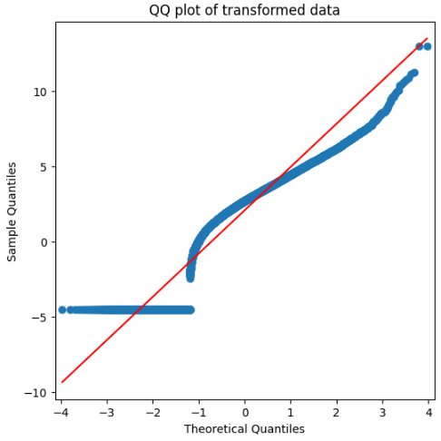

**Fig 2.** Q-Q Plot Transformed Average Gate Arrival Delay Distribution

* 1. Performance Evaluation Metrics

This study selected three metrics to compare the effectiveness and performance of the selected Machine Learning models: RMSE, MSE, and R2. These metrics were selected as performance metrics because they quantify how well a regression model fits a dataset. For example, Chug (2022) states that RMSE is better for comparing accuracy among different regression models. This metric tells how well a model can predict the value of the response variable. The information in **Table 5** is according to the paper by James, Witten, Hastie, & Tibshirani (2013), which explains the importance of these metrics for measuring Regression models, especially the remarks that describe how well a model performs according to each metric.

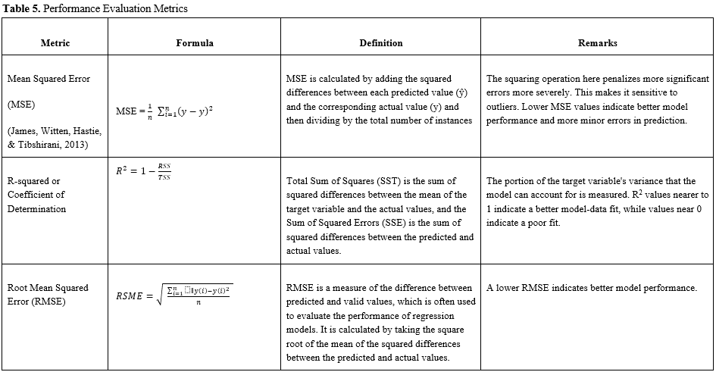

* 1. Regression Models

The following models were used to evaluate and compare the effectiveness of ensemble machine learning models in forecasting the Average Gate Arrival Delay. Two ensemble models, Random Forest Regressor and XGBoost Regressor, a Linear Regression model, K-Nearest Neighbors, and Neural Networks, were the models selected to evaluate the effectiveness of the models.

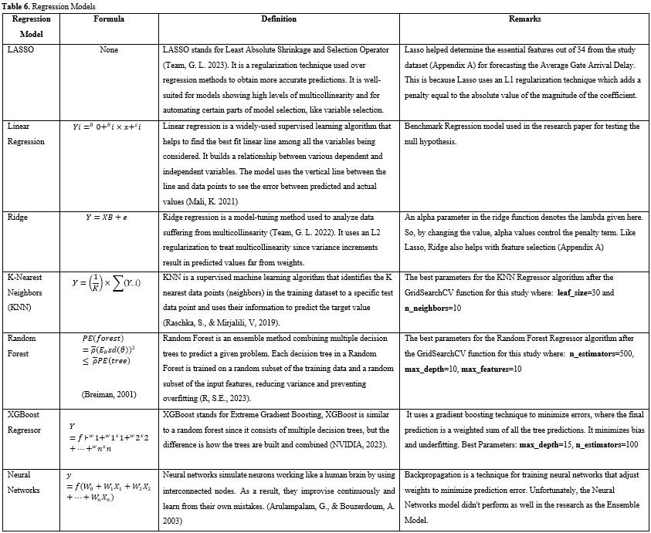

1. COMPARISON AND MODEL OUTCOMES

Four regression models were run; Random Forest, XGBoost, KNNeighbors, and Linear Regression. The results were the following:

**Table 7.** Models Results

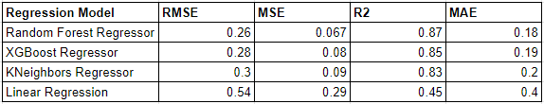

Based on the analysis of **Table 7**, it can be concluded that the Random Forest model outperformed other models in predicting the Average Gate Arrival Delay. The XGBoost Regressor model also performed well and showed comparable results to the Random Forest model. The results suggest that ensemble models, like Random Forest and XGBoost Regressor, have better prediction accuracy for the Average Gate Arrival Delay than other models. Finally, a sequential Neural Network with two hidden layers and a "relu" activation type was developed, resulting, as **Table 8** shows, with a higher MSE and MAE than the Ensemble models.

**Table 8.** NN Model Results



1. FINAL REMARKS

Predicting the average gate arrival delay in the aviation industry is challenging due to the complexity of the involved variables, particularly those beyond human control, such as the Weather. However, our study suggests several factors contribute to increasing or decreasing the average gate arrival time, including taxi-out times, average block delays, arrivals and departures efficiency, and airport capacity. Our findings suggest ensemble machine learning models, such as Random Forest, are better for predicting the average gate arrival delay.

From the final Random Forest Regressor model, which was the ensembled model that outperformed the other models used to forecast the Average Gate Arrival Delay, **Appendix B** can demonstrate the features that are primarily valuable for the model to predict the dependent variable, such as "% On-Time Gate Arrivals," "Arrivals for Metric Computation" and "Average Block Delay," features that could influence in the way of predicting the Average Gate Arrival Delay.

1. CONCLUSION

In conclusion, this study of EWR highlights the significance of accurately predicting average gate arrival delays in the aviation industry. Factors such as weather conditions, taxi-out times, block delays, arrivals and departures efficiency, and airport capacity play crucial roles in determining these delays. By analyzing hourly data from 2018 to 2022 at Newark Liberty International Airport (EWR), we compared various machine learning models for their predictive performance. The results indicate that ensemble models, specifically Random Forest, outperformed other models, including Linear Regression and K-Nearest Neighbors. These findings suggest that ensemble machine learning models can be valuable tools for airports to effectively plan flight connections, optimize gate availability, and enhance overall operational efficiency to minimize average gate arrival delays. However, it is crucial to consider the influence of external factors beyond the scope of this study, such as unpredictable weather events, when utilizing these models for decision-making in real-world scenarios. Future research should focus on further exploring the impact of such factors and refining the models, like the Neural Networks, to improve prediction accuracy in the dynamic aviation environment.

1. REFERENCES

Air Transport Action Group. (2019). *Aviation Benefits Beyond Borders.* Retrieved from <https://aviationbenefits.org/media/177520/atag-aviation-benefits-beyond-borders.pdf>

Aviation system performance metrics (ASPM). *Aviation System Performance Metrics (ASPM) - ASPM Help.* (n.d.). https://aspm.faa.gov/aspmhelp/index/Aviation_System_Performance_Metrics_(ASPM).html

Arulampalam, G., & Bouzerdoum, A. (2003). *A Generalized Feedforward Neural Network Architecture for Classification and Regression.* Neural Networks: the official journal of the International Neural Network Society, 16(5-6), 561–568. https://doi.org/10.1016/S0893-6080(03)00116-3

Balakrishna, P., Ganesan, R., & Sherry, L. (2010). *Accuracy of Reinforcement Learning Algorithms for Predicting Aircraft Taxi-Out Times: A Case-study of Tampa Bay Departures.* Transportation Research Part C: Emerging Technologies, 18(5), 751-762. doi 10.1016/j.trc.2010.03.003.

Bhatia, B. (2018). *Flight Delay Prediction*. California State University. https://scholarworks.calstate.edu/downloads/qr46r081g

Breiman, L. (2001, October 1). *Random Forests*. Springer. https://link.springer.com/content/pdf/10.1023/A:1010933404324.pdf

Bureau of Transportation Statistics (BTS).(n.d) - *Airline On-Time Performance*: Retrieved from : <https://www.bts.gov/topics/airlines-and-airports/airline-time-performance>

Chugh, A. (2022, March 16). *Mae, MSE, RMSE, coefficient of determination, adjusted R squared - which metric is better?* Medium. https://medium.com/analytics-vidhya/mae-mse-rmse-coefficient-of-determination-adjusted-r-squared-which-metric-is-better-cd0326a5697e#:~:text=For%20comparing%20the%20accuracy%20among,better%20choice%20than%20R%20Squared.

Diana, T. (2018). *Can Machines Learn How to Forecast Tax-Out Time? A Comparison of Predictive Models Applied to the Case of Seattle/Tacoma International Airport*. Journal of Air Transport Management, 73, 1-11. doi: 10.1016/j.jairtraman.2018.10.003.

Federal Aviation Administration. (2014). *ACRP Report 104: Guidebook for Selecting Methods to Monitor Airport and Aircraft Deicing Materials*. Transportation Research Board. Retrieved from<https://www.nap.edu/read/18920/chapter/1>

Farzan, R., & Wu, B. (2019). *Prediction of Flight Delays using Machine Learning Techniques*. Journal of Air Transport Management, 78, 19-26.

Flightstats.com - *Newark Liberty International Airport (EWR) Statistics*: <https://www.flightstats.com/v2/airport-stats/EWR>

Grabowski, B. (2016, August 10). *"P < 0.05" Might Not Mean What You Think: American Statistical Association clarifies P values.* Journal of the National Cancer Institute. Retrieved May 6, 2023, from https://www.ncbi.nlm.nih.gov/pmc/articles/PMC5017929/#:~:text=P%20%3E%200.05%20is%20the%20 probability, that%20 no%20 effect%20was%20 observed.

Hale, J. (2021, December 13). *Scale, Standardize, or Normalize with Scikit-Learn*. Medium. https://towardsdatascience.com/scale-standardize-or-normalize-with-scikit-learn-6ccc7d176a02#:~:text=let’s%20start%20scaling!-,MinMaxScaler,shape%20of%20the%20original%20distribution.

Huang, Z., Li, H., Chen, X., & Chen, Y. (2020). *Predicting Flight Delays: A Machine Learning Approach Based on Weather Data*. IEEE Transactions on Intelligent Transportation Systems, 21(10), 4173-4183.

Hoberg, K., & Wang, H. (2010). *Airport Operations: Delay and Capacity Analysis*. Springer.

James, G., Witten, D., Hastie, T., & Tibshirani, R. (2013). *An Introduction to Statistical Learning*. Springer.

Katz, S. (2017). *Predicting Taxi Demand with Convolutional Neural Networks. Machine Learning Final Project*. Retrieved from <http://cs229.stanford.edu/proj2017/final-reports/5243248.pdf>.

Khan, M. (2022, November 17). *How to Detect Outliers*. Data Drive. Retrieved May 5, 2023, from https://godatadrive.com/blog/how-to-detect-outliers

Kudryavtseva, E., Gorbachevskiy, M., Markov, A., & Gorshkov, A. (2021). *Comparative Analysis of Reinforcement Learning Methods for Control of a Quadrotor UAV*. Aerospace, 8(6), 152. doi 10.3390/aerospace8060152.

Kuhn, M., & Johnson, K. (2019). *Applied Predictive Modeling*. Springer.

Kuncheva, L. I. (2014). Combining Pattern Classifiers: Methods and Algorithms. John Wiley & Sons.

Lambelho, M., Mitici, M., Pickup, S., & Marsden, A. (2019). *Assessing strategic flight Schedules at an Airport Using Machine Learning-Based Flight Delay and Cancellation Predictions*. Journal of Air Transport Management, 81, 101679. doi: 10.1016/j.jairtraman.2019.101679.

Lee, S., Park, S., & Ryu, K. (2019). *Predicting Flight Delays Using Machine Learning Algorithms: A Case Study of Korean Domestic Airlines*. Journal of Air Transport Management, 77, 40-50.

Li, J., Zeng, G., Zhou, J., Chen, W., & Yang, L. (2021). *An Efficient and Accurate Regression Model for Forecasting Airport Gate Arrival Times Based on Weather Conditions and Flight Delays*. Journal of Air Transport Management, 91, 101995.

Lin, T. Y., & Yu, Y. H. (2018). *A Simulation-Based Analysis of Aircraft Departure Flow Control Strategies Under the Integrated Arrival and Departure Operation.* Journal of Air Transport Management, 71, 129-140.

Liu, H., Li, Y., Li, X., Zhang, H., & Zhang, Y. (2020). *Flight Delay Prediction Based on KNN Regression Model.* 2020 12th International Conference on Measuring Technology and Mechatronics Automation (ICMTMA), 476-480.

Maity, R. (2021, July 24). *Min-max scaler*. Medium. https://medium.com/@ranjitmaity95/min-max-scaler-b2411ab3136d

Mali, K. (2023, April 20). *Everything You Need to Know About Linear Regression!* Analytics Vidhya. https://www.analyticsvidhya.com/blog/2021/10/everything-you-need-to-know-about-linear-regression/

NVIDIA. (n.d.). *What is XGBoost?* NVIDIA Data Science. https://www.nvidia.com/en-us/glossary/data-science/xgboost/#:~:text=XGBoost%2C%20which%20stands%20for%20Extreme,%2C%20classification%2C%20and%20ranking%20problems.

Pannell, R. (2022, October 4). The box-cox transformation: What it is and how to use it. LeanScape. Retrieved May 5, 2023, from https://leanscape.io/the-box-cox-transformation-what-it-is-and-how-to-use-it/

Plummer, A. (2022, September 16). Box-Cox Transformation and target variable: Explained. Built-In. https://builtin.com/data-science/box-cox-transformation-target-variable

Ouyang, Y., Fu, X., Hong, L., & Chen, N. (2015). *Measuring Air Traffic Flow Management Delay: A Review and Data Analysis*. Journal of Air Transport Management, 42, 17-26. doi: 10.1016/j.jairtraman.2014.10.001

R, S. E. (2023, April 26). *Understand random forest algorithms with examples (updated 2023)*. Analytics Vidhya. https://www.analyticsvidhya.com/blog/2021/06/understanding-random-forest/

Rajendran, S., Srinivas, S., & Grimshaw, T. (2021). *Predicting Demand for Air Taxi Urban Aviation Services Using Machine Learning Algorithms*. Journal of Air Transport Management, 92, 101947. doi: 10.1016/j.jairtraman.2021.101947.

Rumelhart, D. E., Hinton, G. E., & Williams, R. J. (1986). *Learning Representations by Back-Propagating Errors*. Nature, 323(6088), 533-536.

Raschka, S., & Mirjalili, V. (2019). Python Machine Learning. Packt Publishing.

Tang, Y. (2021). *Airline Flight Delay Prediction Using Machine Learning Models*. In Proceedings of the 2021 5th International Conference on E-Business and Internet (ICEBI '21) (pp. 151-154). [Retrieved from: https://doi.org/10.1145/3497701.3497725](https://doi.org/10.1145/3497701.3497725)

Team, G. L. (2023, January 12). *A Complete Understanding of Lasso Regression*. Great Learning Blog: Free Resources that Matter to shape your Career! Retrieved April 23, 2023, from https://www.mygreatlearning.com/blog/understanding-of-lasso-regression/#:~:text=Lasso%20 regression%20is%20a%20 regularization, i.e., %20models%20 with%20 fewer%20parameters).

Team, G. L. (2022, November 16). *What is Ridge Regression?* Great Learning Blog: Free Resources that Matter to shape your Career! Retrieved April 26, 2023, from https://www.mygreatlearning.com/blog/what-is-ridge-regression/#:~:text=Ridge%20 regression%20is%20a%20 model, away%20from%20the%20 actual%20 values.

Wang, Z., Liang, M., & Delahaye, D. (2018). *A Hybrid Machine Learning Model for Short-Term Estimated Time of Arrival Prediction in Terminal Maneuvering Area*. Journal of Air Transport Management, 70, 72-82. doi: 10.1016/j.jairtraman.2018.07.003\

Zografos, K. G., & Madras, M. A. (2011). *Airport Capacity and Congestion: A Study of Peak Hour Capacity, Performance, and Delays*. Transportation Research Part A: Policy and Practice, 45(3), 209-226. doi 10.1016/j.tra.2010.09.014

APPENDIX

APPENDIX A

* LASSO - Lasso Top 10 and Bottom 10 with Coefficient != 0

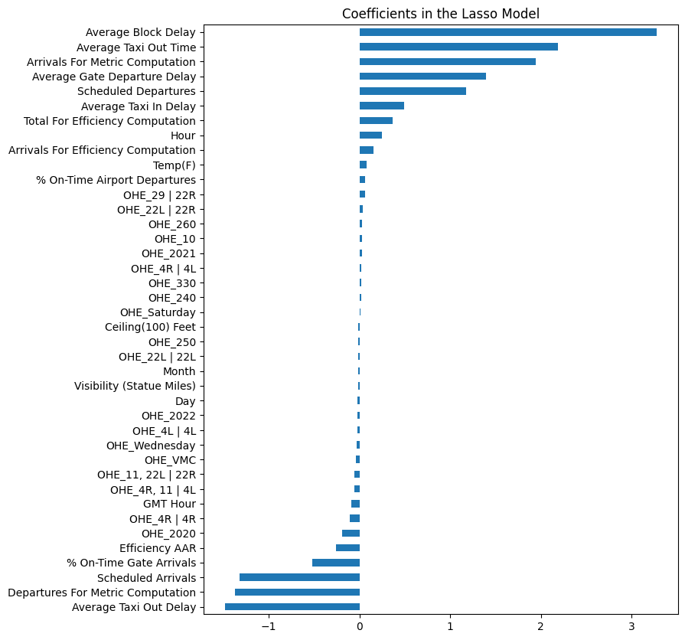

* RIDGE - Ridge Top 10 and Bottom 10 with Coefficient != 0

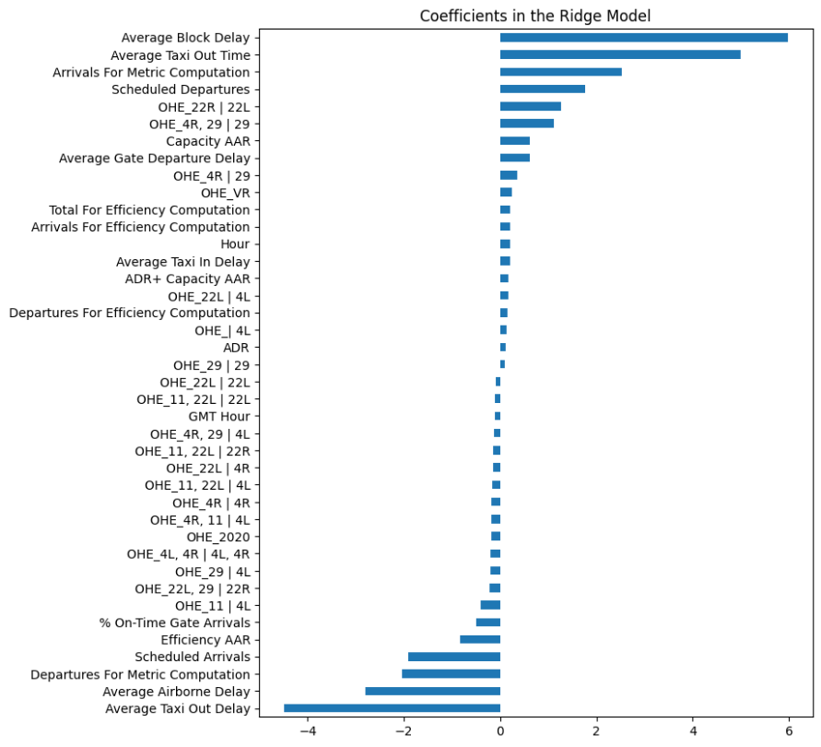

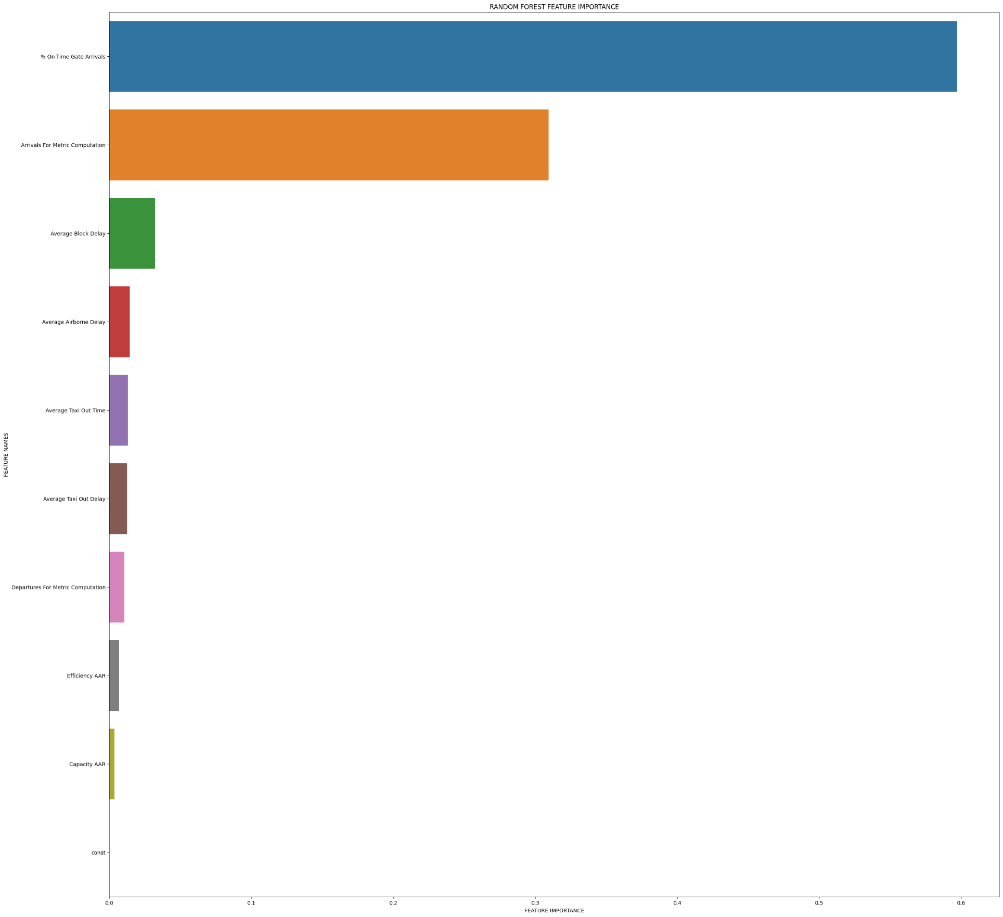APPENDIX B – Random Forest Feature Importance

1. Lin, T. Y., & Yu, Y. H. (2018). A simulation-based analysis of aircraft departure flow control strategies under the integrated arrival and departure operation. Journal of Air Transport Management, 71, 129-140.
2. Zografos, K. G., & Madas, M. A. (2011). Airport capacity and congestion: A study of peak hour capacity, performance, and delays. Transportation Research Part A: Policy and Practice, 45(3), 209-226. doi: 10.1016/j.tra.2010.09.014
3. Air Transport Action Group. (2019). Aviation Benefits Beyond Borders. Retrieved from https://aviationbenefits.org/media/177520/atag-aviation-benefits-beyond-borders.pdf
4. Ouyang, Y., Fu, X., Hong, L., & Chen, N. (2015). Measuring air traffic flow management delay: A review and data analysis. Journal of Air Transport Management, 42, 17-26. doi: 10.1016/j.jairtraman.2014.10.001
5. Hoberg, K., & Wang, H. (2010). Airport Operations: Delay and Capacity Analysis. Springer.
6. Federal Aviation Administration. (n.d.). Retrieved May 6, 2023, from https://aspm.faa.gov/
7. ASPM efficiency: Definitions of variables. ASPM Efficiency: Definitions of Variables - ASPMHelp. (n.d.). Retrieved April 23, 2023, from https://aspm.faa.gov/aspmhelp/index/ASPM_Efficiency__Definitions_of_Variables.html
8. ASPM airport analysis: Definitions of variables. ASPM Airport Analysis: Definitions of Variables - ASPMHelp. (n.d.). Retrieved April 23, 2023, from https://aspm.faa.gov/aspmhelp/index/ASPM_Airport_Analysis__Definitions_of_Variables.html
9. Aviation system performance metrics (ASPM). Aviation System Performance Metrics (ASPM) - ASPM Help. (n.d.). https://aspm.faa.gov/aspmhelp/index/Aviation_System_Performance_Metrics_(ASPM).html
10. Maity, R. (2021, July 24). Min-max scaler. Medium. https://medium.com/@ranjitmaity95/min-max-scaler-b2411ab3136d
11. Hale, J. (2021, December 13). Scale, standardize, or normalize with Scikit-Learn. Medium. https://towardsdatascience.com/scale-standardize-or-normalize-with-scikit-learn-6ccc7d176a02#:~:text=let’s%20start%20scaling!-,MinMaxScaler,shape%20of%20the%20original%20distribution.
12. NY/NJ/PHL airspace redesign documentation. NY/NJ/PHL Airspace Redesign Documentation | Federal Aviation Administration. (n.d.). Retrieved May 5, 2023, from https://www.faa.gov/air_traffic/nas/nynjphl_redesign/documentation
13. Eddie_4072. (2023, April 26). How to handle missing data: A step-by-step guide (updated 2023). Analytics Vidhya. Retrieved May 4, 2023, from https://www.analyticsvidhya.com/blog/2021/05/dealing-with-missing-values-in-python-a-complete-guide/
14. Pandas-profiling. PyPI. (n.d.). Retrieved May 6, 2023, from https://pypi.org/project/pandas-profiling/
15. Suresh, A. (2020, December 1). How to remove outliers for machine learning? Medium. Retrieved May 4, 2023, from https://medium.com/analytics-vidhya/how-to-remove-outliers-for-machine-learning-24620c4657e8#:~:text=It%20 increases%20the%20error%20 variance, to%20detect%20and%20remove%20 outliers.
16. Khan, M. (2022, November 17). How to detect outliers. Data Drive. Retrieved May 5, 2023, from https://godatadrive.com/blog/how-to-detect-outliers
17. Frost, J. (2022, November 7). Null hypothesis: Definition, rejecting &amp; examples. Statistics By Jim. Retrieved May 5, 2023, from https://statisticsbyjim.com/hypothesis-testing/null-hypothesis/
18. Grabowski, B. (2016, August 10). "P &lt; 0.05" might not mean what you think: American Statistical Association clarifies P values. Journal of the National Cancer Institute. Retrieved May 6, 2023, from https://www.ncbi.nlm.nih.gov/pmc/articles/PMC5017929/#:~:text=P%20%3E%200.05%20is%20the%20 probability, that%20 no%20 effect%20was%20 observed.
19. National Academies of Sciences, Engineering, and Medicine. 2014. Defining and Measuring Aircraft Delay and Airport Capacity Thresholds. Washington, DC: The National Academies Press. https://doi.org/10.17226/22428.
20. Pannell, R. (2022, October 4). The box-cox transformation: What it is and how to use it. LeanScape. Retrieved May 5, 2023, from https://leanscape.io/the-box-cox-transformation-what-it-is-and-how-to-use-it/
21. Plummer, A. (2022, September 16). Box-Cox Transformation and target variable: Explained. Built In. https://builtin.com/data-science/box-cox-transformation-target-variable